CHAPTER 36
DIFFRACTION
Discussion Questions

Q36.1 To observe diffraction effects the size of the aperture must be similar to the wavelength. The wavelengths of sound waves and water waves range from a few centimeters to several meters and we commonly experience apertures of this range of sizes. But visible light has a wavelength on the order of 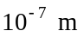 and apertures of this size don’t occur for objects that we normally experience. It is the short wavelength, not the high speed, that makes diffraction effects for light less common.

Q36.2 Fresnel and Fraunhofer diffraction are based on the same physical process, it is just their mathematical description that is different. The Fraunhofer diffraction regime allows for simplifying approximations.

Q36.3 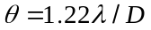 is the smallest angular separation that can be resolved. Small corresponds to larger resolving power. (a) Smaller 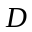 increases and decreases the resolving power. (b) Larger 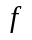 means smaller and this decreases and increases the resolving power. (c) Larger means larger and decreases the resolving power.
Q36.4 From Eq.(36.3) we find the width of the central maximum to be 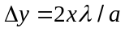. (a) Decreasing increases the width of the central maximum. (b) Decreasing increases and this increases the width of the central maximum. (c) Decreasing does decrease the width of the central maximum. (d) Decreasing does decrease the width of the central maximum.

Q36.5 The first dark fringe on one side of the central maximum is at an angle given by 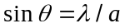. This fringe doesn’t appear on the screen if 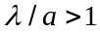 so 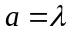 is the maximum slit width for which no dark fringe is seen.

Q36.6 The phasor diagrams are similar to those in Figure 36.14 in the textbook. An interference minimum occurs when the phasors add to zero. (a) The phasor diagram is given in Figure DQ36.6a. There is destructive interference between the light through slits 1 and 3 and between 2 and 4. (b) The phasor diagram is given in Figure DQ36.6b. There is destructive interference between light through slits 1 and 2 and between 3 and 4. (c) The phasor diagram is given in Figure DQ36.6c. There is destructive interference between light through slits 1 and 3 and between 2 and 4. Note that maxima occur when 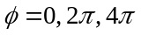 etc. Our analysis shows that there are three minima between the maxima at 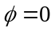 and 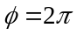. This agrees with the general result that for 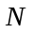 slits there are 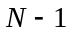 minima between each pair of principal maxima.

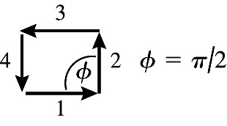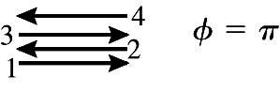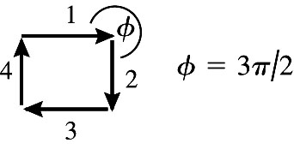
(a) (b) (c)
Figure DQ36.6

Q36.7 For eight slits the phasor diagrams must have eight vectors. At a minimum the phasors for all slits sum to zero. The diagrams for 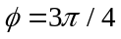 and for 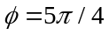 are sketched in Figure DQ36.7a and the diagrams for 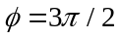 and for 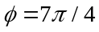 are sketched in Figure DQ36.7b. For , and totally destructive interference occurs between slits four apart. For , totally destructive interference occurs with every second slit.
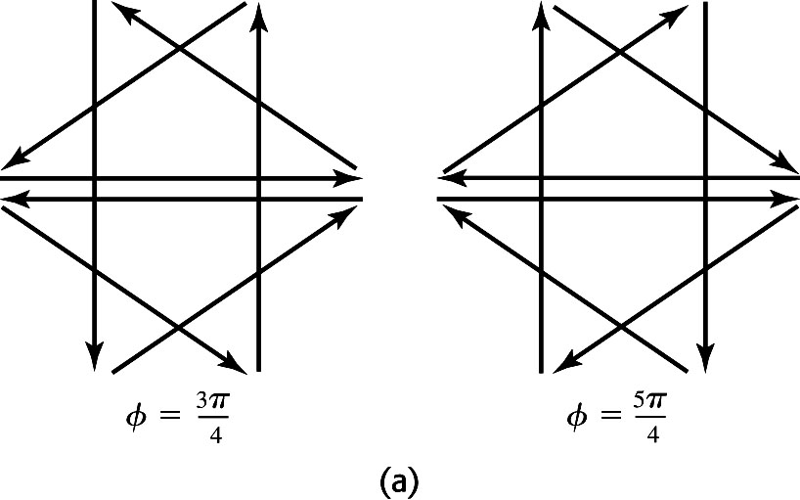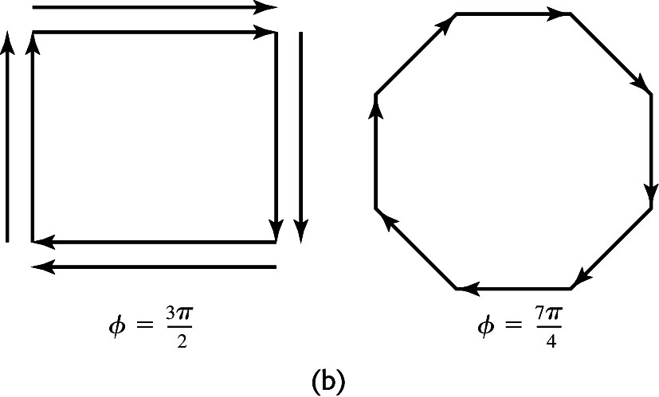
Figure DQ36.7

Q36.8 The raindrop acts as an aperture. If the drop is small enough the central diffraction pattern for each wavelength is as wide as the angular spread of the rainbow. This will happen when the drop size is on the order of the wavelength of the visible light.

Q36.9 The narrow horizontal width increases the horizontal spread of the sound in the central diffraction maximum. If the audience is distributed horizontally but not vertically it is not desirable to have a wide diffraction maximum in the vertical direction, so the vertical dimension of the speaker is somewhat larger than the wavelength of the sound. If the audience is also spread in the vertical direction the speaker would need also to be narrow in the vertical direction to spread the sound in this direction, so should be more nearly square.
Q36.10 High frequency sounds have smaller wavelength. The small speaker diameter makes 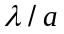 larger so the central diffraction maximum for the high frequency sound waves is spread over a wider angular range.

Q36.11 In this application we want the central diffraction maximum for light from the pits to be narrow. This requires a small . Narrow pits (small ) means more information stored in the disk, but a small requires a small to keep and the width of the diffraction maximum small.

Q36.12 The minimum angular separation of objects that can be resolved is . Resolving finer detail means smaller and this happens for smaller . The Hubble can see finer detail in the ultraviolet.

Q36.13 (a) For a minimum to occur, the sum of all phase differences between the slits must add to zero, so the phasor diagram closes on itself and the sum of all the phasors is zero. This requires that 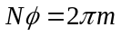, for some integer m. Therefore, 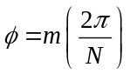. But when 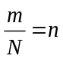, where n is an integer, 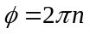. In this case all the phasors are in phase and their magnitudes add to give a principal maximum. (b) There are values of m that satisfy between the value 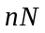 and 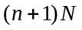, where n is an integer.

Q36.14 In x-ray diffraction with a crystal the slit spacing is the separation between atomic planes in the crystal. A typical value of in this application is 0.1 nm (Example 36.5). The wavelength of visible light is about 500 nm, so 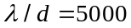 and no interference fringes can be seen, only the central bright fringe.

Q36.15 With a grating the bright fringes are much narrower. The centers of the fringes can be measured more accurately and there is less overlap of fringes from different wavelength than with two slits.

Q36.16 The phase difference for the radio signal received by the different antennas produces an interference pattern when the signal from all antennas is combined coherently. The sharp interference fringes allow for accurate determination of the wavelengths in the signal, just as a diffraction grating can be used to measure the wavelengths in a sample of visible light.

Q36.17 The image will be distorted when 500-nm light is used for viewing. In Fig.36.29b the different wavelength will produce a maximum in the diffracted wave at a point different from 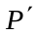. The centers of successive bright fringes on the developed film will differ by integer wavelengths at different points.

Q36.18 The maxima in the diffracted wave will occur at different points for each wavelength in the white light and no image will be seen.

Q36.19 Bright and dark areas of the image will be opposite what they are in the object. That is, where the object is bright the image will be dark.

